Bangladesh University of Engineering and Technology
Department of Computer Science and Engineering

CSE 316
Microprocessors and Microcontrollers Sessional

Experiment 4
DC Motor control using Microprocessor

GOAL:
Understanding how microprocessor can be used to start, stop, and control the direction of rotation of dc motors.

EXPERIMENTAL TOOLS AND MATERIALS: MTS-88.C, I/O Board-07, Breadboard with +12V power supply and 3 (three) push-buttons.

Description of I/O Board-07:
I/O Board-07 has some connectors and relays on board. Connectors are arranged in two rows --- connectors CN01 to CN09 in one row at the top of the board, while connectors CN10 to CN17 in another row at the bottom of the board. Top row connectors are connected to Port A while bottom row connectors and relays are connected to Port B.
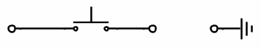
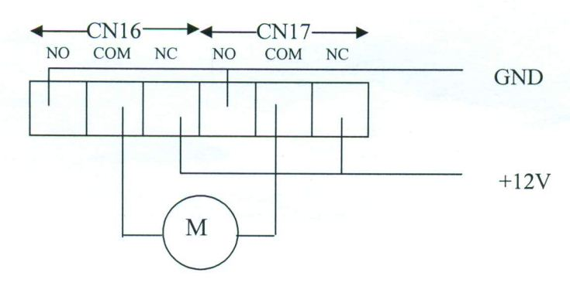
Each of CN02-CN09 connectors has two connecting terminals, + and -, the + one is to be connected to +12V power supply through push button switch and - one is to be connected to GND as shown in the Figure 1. Connector CN(9-i) is connected to Port PA_{i} where 0<=i<=7. When push button is pressed the corresponding pin of Port A is low and the other pins remain high.
PushButton
+
-
CNi
Figure 1
Figure 2
Port PB_{i} is connected to relay RLY(8-i) where 0<=i<=7. RLYi is connected to connector CN(9+i) where 1<=i<=8. So, port PBi controls connector CN(l7-i) through relay RLY(8-i). Each of the CN10 to CNl7 connectors contains three connecting terminals --- labeled NO (normally open), COM (common), and NC (normally close). NO is to be connected to GND, NC to +12V supply and COM is output terminal which gives GND or +12V depending on value of port B bits. So, COM terminals can be used to drive 12V DC or Stepper motor or other devices that need 12V power supply. Typical connection between connectors CNx where 10<=x<=17 and a motor is shown in Figure 2.

PROCEDURE:
- Connect I/O Board-07 with the system board by 40 pins flat cable.
- Insert 3 push-buttons in bread-board and connect them with I/O board-07. Pushbuttons will be used to control the motor. Pressing one pushbutton will stop the running motor. Pressing second one will start the motor to rotate in one direction while pressing the third one will start the motor in another direction.
- Connect CN01to proper power supply terminals.
- Write an 8088 assembly language program that will control the motor as stated above based on push-button press. Which push-button will do what job and be connected to which connector and which relays will control the motor will be made known during lab class.

