Bangladesh University of Engineering and Technology (BUET)
Department of Computer Science and Engineering (CSE)

CSE 210 Digital Electronics and Pulse Techniques Sessional

Experiment# 6: Study of diode clipping circuits

CKT diagram
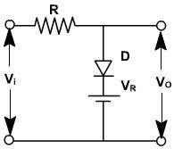 | 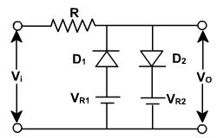
Fig. 1: Simple clipping circuit | Fig. 2: Two-level clipping circuit

Apparatus:
- Diode 1N4007 2 pcs
- Resistor 100KΩ 1 pc

Procedure:
- Fig. 1:
  - Observe the output for V_{i}=10V p-p 50 Hz sine wave and V_{R}=3V.
  - Reverse the diode and observe its effect.
  - Reverse V_{R} and observe its effect.
  - Reverse both the diode and V_{R}, and observe its effect.
- Fig. 2:
  - Observe the output for V_{i}=10V p-p 50 Hz sine wave and V_{R1}=3V and V_{R2}=4V.
  - Reverse V_{R1} and observe its effect.

Question:
- In Fig. 2, what would happen for the following:
  - Reverse only V_{R2}.
  - Reverse both V_{R1} and V_{R2}.
- What will be the transfer characteristics graphs for all cases you have experimented with and you have considered in the previous question?

Report:
Report should cover the following points:
- Objective
- Circuit diagram and input-output wave shapes
- Answer to the questions
- Discussion of the findings
- Applications of your study

